**Mayhem in May Team Entry**

**28th & 29th May 2016**

Team Name _________________________________________

Landline _________________________________________

Mobile _________________________________________

Address _________________________________________

County _________________________________________

Post Code _________________________________________

Email _________________________________________

No. of Team Members

Names of Team Members

1. _____________________________
2. _____________________________
3. _____________________________
4. _____________________________
5. _____________________________

**Competition Categories**

There are the 4 compulsory categories that count toward Grand

Champion. All 4 categories will be judged on Sunday 29th May.

Pork Shoulder Pork Ribs

Beef Brisket Chicken

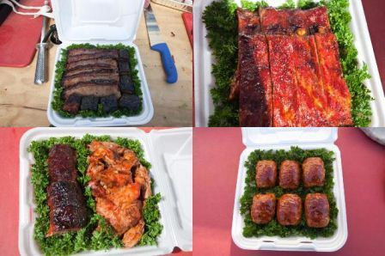

**Terms, conditions and waiver of liability.**

By accepting this entry, I, the undersigned, intending to be legally bound, hereby, for myself, my heirs, executors, and administrators, waive and release any and all rights and claims for damages I may have against the organisers, their representatives, successors, and assigns for any and all injuries suffered by me in this event.

Further, I hereby grant full permission to the organisers and/or agents authorised by them, to use any photographs, video tapes, motion pictures, recordings, or any other record of this event for any legitimate purpose. Additionally, if I win in the optional categories, I grant full permission to the organisers and/or agents authorised by them, to use my recipe for publicity purposes.

By Ticking This Box you Accept Terms & Conditions set out by IBQN

email form to [events@bbbqs.com](mailto:events@bbbqs.com) you will receive bank transfer details once your form has been received.